2017
STANDARD RECORDING GUIDELINES
FOR THE BLW DAY OF SERVICE RECORDINGS

STANDARD RECORDING GUIDELINES

FOR THE BLW DAY OF SERVICE RECORDINGS

INTRODUCTION
The International Day of Service is a special day set side by our BLW Nation when each member, partner and friend of our great ministry can give a gift to Pastor by rendering acts of service and kindness as an individual to someone in their sphere of contact in honor of our Man of God.
it is a golden opportunity for us to share our love for our man of God Pastor Chris and showcase the impact we are making in the lives of others as a result of his inspiration.
To this end, good media coverage of the service is required from every individual or group that embarks on Service Projects during the BLW Intl Day of Service as detailed below:
- A Brief Write-Up
- Video Recordings
- Audio Recordings
- Pictures

These recording guidelines serve as a working document and guide for any standard excellent recording for the BLW Day of Service.

APPEARANCE - Costume: This should be communicated to the interviewees before he/she comes on set. All the brethren and the reporter should be adorned in BLW Day of Service branded paraphernalia.

VIDEO FORMAT - Format: PAL, HD (16:9)

LOCATION/SET –In this scenario, the location is expected to be the location where the service is being carried out. The streets, orphanage, market area, schools etc

THE RECORDING SCRIPT – There should be a production script in which all the details about the recording are enumerated; It should be clear and unambiguous. Every member of the team should have an understanding of what everyone is expected to do. The details of the script would vary depending on the type of recording it is.

SET UP GUIDELINES

Kindly Note the following when setting up:
- For an indoor recording, the set should be as well lit as possible. -
- Avoid shadows as much as possible, except where the shadow is part of the concept for the video.
- The tiepin microphone should be neatly placed on the subjects outfit close to the mouth, without being unnecessarily obvious and distracting.
- The audio must be audible. KINDLY ENSURE THAT THE QUALITY OF THE AUDIO IS EXCELLENT before you start recording.
- Ensure you use a pair of head phones to monitor the audio during the recording.
- The interviewee should be briefed properly before commencing the recording.
- Please use tripods where possible to ensure that your shots are stable.
- Please be very mindful of the background of the subject. THE BACKGROUND MUST BE EXCELLENT. Depending on the type of recording, the background should reflect the mode and ambience to be conveyed to the intended audience.
- Do not forget to press the record button.
- The shots must capture the subject in action, relating him/her with the location and the activity he/she is carrying out in service.

It is always important to carefully choose the set for the recording. You may need to do some rearrangements of the location to suit the purpose.

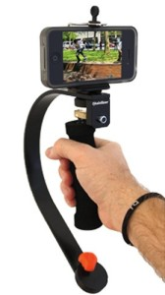
RECORDING WITH MOBILE PHONE
Good smart phones with a great camera can be used for this recording. Below are some of the things you should take note off while recording with your mobile phone.

#1 – Good Lighting is Critical
Proper lighting has a huge impact on Smart Phone cameras because they have smaller image sensors and lenses. Try as much as possible to shoot your video in brightly lit areas.

#2 – Stay Steady
If you don’t want your video footage to come out distorted, blurred, or distorted, try to keep your phone steady while recording. Use both hands to hold your smartphone as close as possible to your body as you record the video.

#3 – The Audio Matters as Much as the Video
While you want your video to look good, the quality of your audio is very important –Use your hand to cover around the phone’s microphone [but don’t completely cover it]. This way, unwanted noise can be reduced, which might give your final product a chance.

#4 – Get Close to Your Subject
Staying physically closer to your subject ensures better image quality, less digital noise and better focus in your videos since most smartphones use a digital zoom rather than optical zoom.

#5 – Avoid Vertical Video Syndrome
Hold your phone horizontally so that videos played back on other screens [virtually everywhere] will look fine. This is very important.
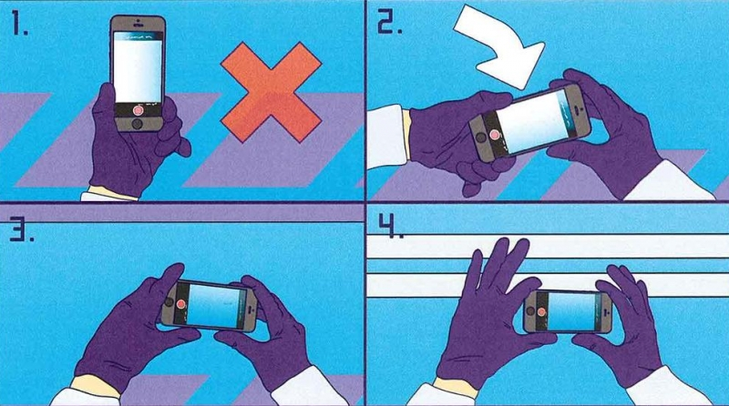

#6 – Take full advantage of your selfie camera and stick
Your selfie stick has a lot of advantages especially when it’s just you on location – you can use your selfie camera with or without a stick for both still and video resodings. You can also use it for interviews just step our of ranege and let your interviewee do the talking.
Hold your phone horizontally so that videos played back on other screens [virtually everywhere]

For this peculiar kind of recording, you want to get your subjects on location working.
- The background must not be a distraction to the audience - The background must be very good, except there is something to communicate in the “badness” of the background, for instance, where you want to capture the ‘Before’ & ‘After’ of a scene.

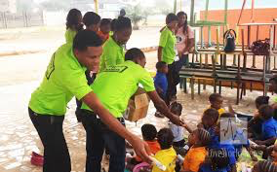
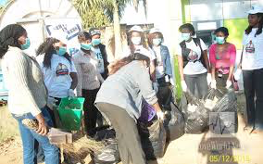

- The Service in Progress banner must be in your shot.
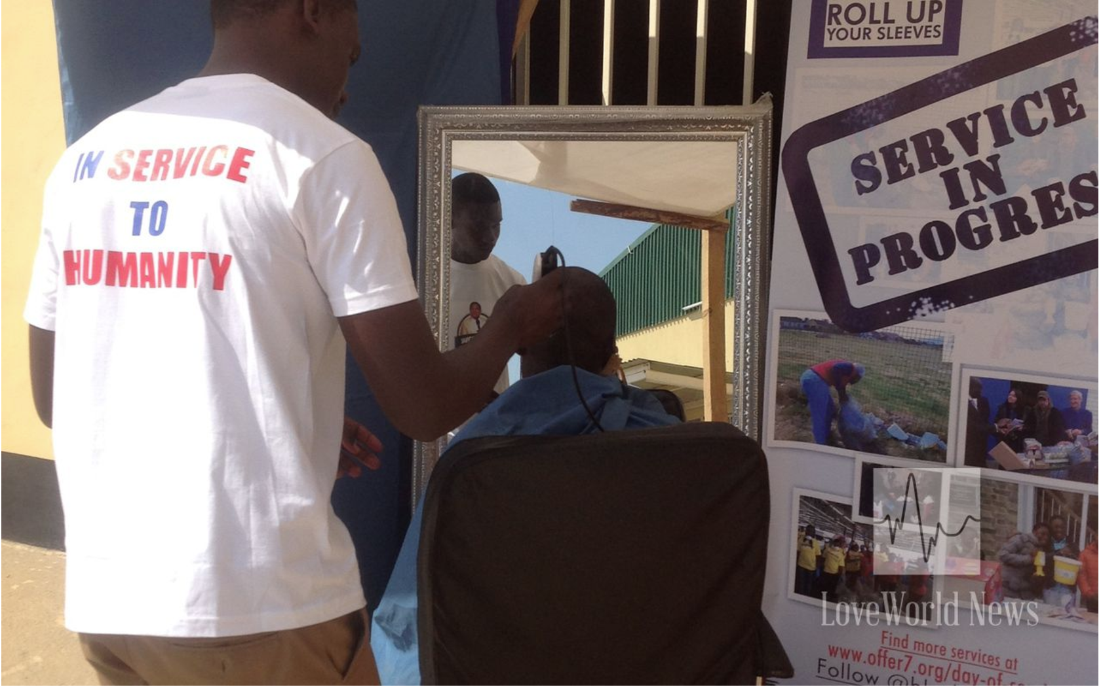

* If in a noisy place, the audio must be closely monitored in order to ensure that the interviewee is audible in spite of the noise in the environment.

SUGGESTED CAMERA SHOTS WITH THE REPORTER
Kindly find below, some of the types of shots we would propose for these recordings.

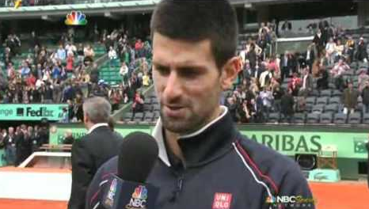
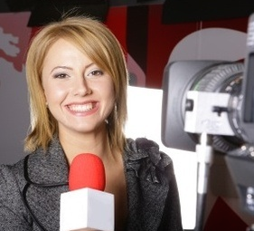

- Ensure an overview shot in front of the Sign Board with the name of the organization, if any, alternatively take a location that best defines where you are. This will tell us the place or location before we even start seeing what you are doing there…

- INTERVIEW of beneficiaries on location: [2 minutes duration EACH speaker]
The reporter must have been well briefed before the commencement of the recordings so that in questioning the interviewees, the reporter carries them along well, and is able to elicit the right answers and responses. He or she must have been told the BLW day of Service is in honor of Pastor Chris.

In such a situation, the interviewee answering the question should please look into the camera, not at the presenter.
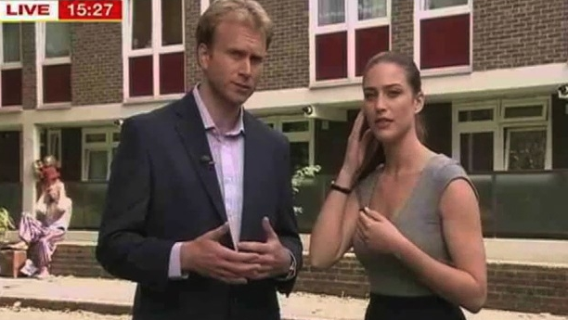
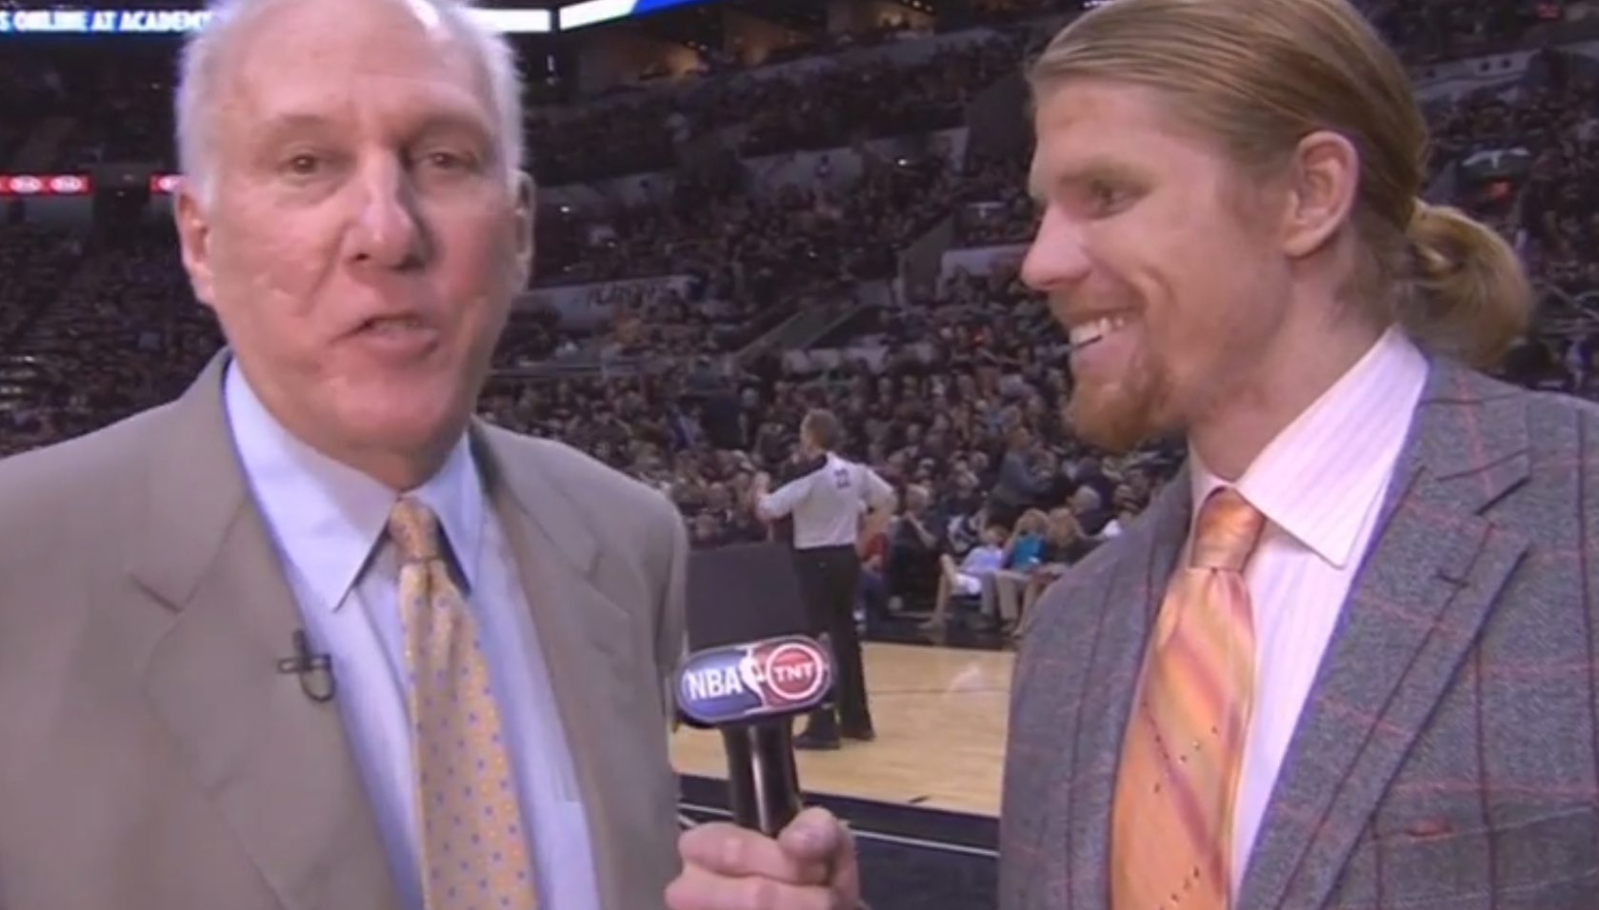
Kindly see the pictures below:

*When asking the questions, the reporter should look at the interviewee, but while he/she is answering the question, the reporter can either look at the interviewee or at the camera, (like in the pictures above).
- It should be interactive and inspiring
- It should express how they feel about the services provided
- It should include a message of gratitude to the celebrant.

- INTERVIEW of Group on location: [2 minutes duration EACH speaker]
Set up the camera for interview in such a way as to capture the interviewee with the location and on-going exercise in the back background and the Service in Progress banner visible.

NOTE that this could also be a “selfie interview” as seen in the image below:
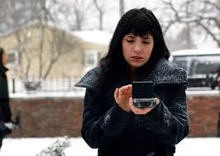

Sample Questions
- What is your name and what Church/Group are you from?
- How excited are you about the BLW Day of Service?
- How has this impacted you personally?
- What do you want to say to our man of God for this opportunity?
Please place microphones close the mouth but not too close as to have bop sounds or breathing.

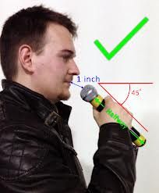

KIND REMINDERS
  - For the recordings of environments in really bad state, the camera man should record the ‘Before’, capturing the status of the area or location before the day of service commenced.

  - These ‘Before’ shots should be wide shots revealing as much as possible, where necessary, the camera man can zoom in to capture more details, and pull out to relate the details with the actual location.

  - The ‘After’ shots would naturally capture the improved state of the location after the day of service. The camera man should endeavor to record the scene exactly the way it was recorded in the previous ‘Before’ shot, this is to allow for some creativity in post production where the editor may want to show a very obvious change and improvement.

Every shot is important. E.g recording the environment sights and sounds of the location, moving vehicles, the people working in a rhythm. Some may be shots to embellish the production. *Please see pictures below

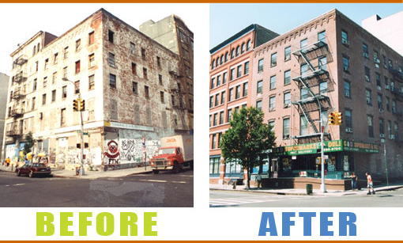

Picture 1
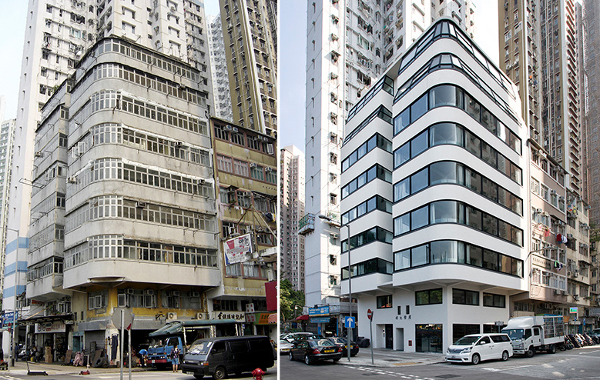

Picture 2

PLEASE NOTE THE FOLLOWING KINDS OF PICTURES TO TAKE WHEN TAKING PICTURES:
- Establishment shot – This is a wide shot of the area
- Please take the picture in such a a way that the picture shows the entire arena, this is to show the location of the project site.
- When shooting indivduals or groups, ensure there isn't too much space between the head of your subject and the top of the picture (medium headroom)
- As much as possible, whatever is captured on video should also be photographed.
- Take pictures of beneficiaries as a group if allowed.
- Take pictures with the beneficiaries
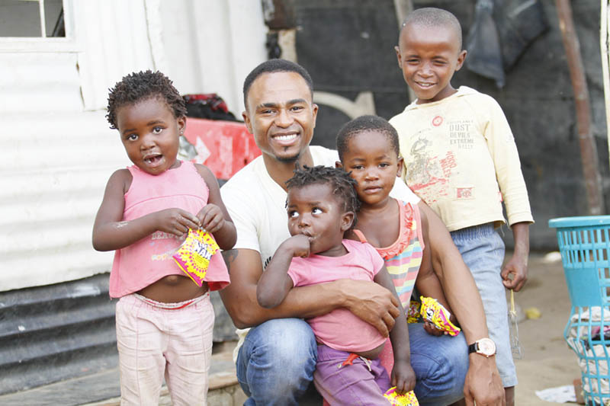

- Take pictures of yourself or the team in front of the signboard or at the gate [where applicable]
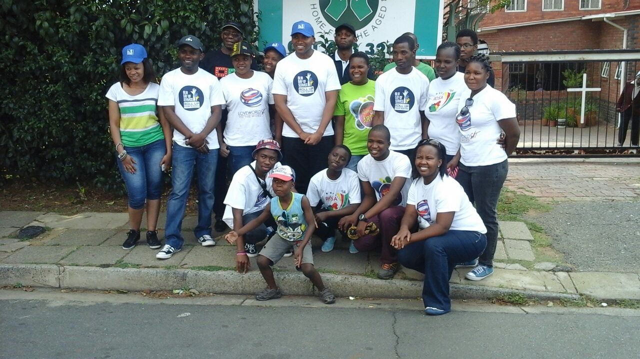

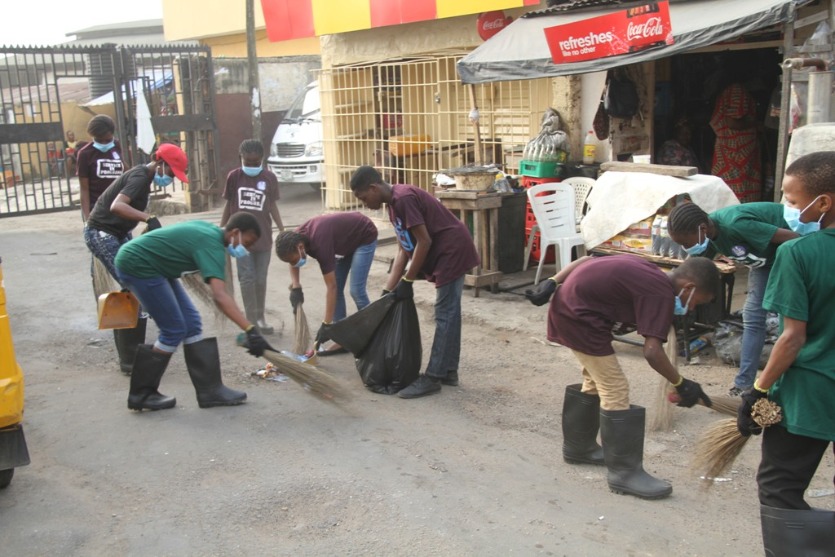
- Get expressive shots of people working, if you’re alone, get someone to take your picture or use a selfie stick.
- Be mindful of the surrounding background and light flare in the shots - Ensure you are backing the light source as the photographer, so the light is on your subject.

- Points to note when taking the pictures of the children
- Go down to the height of the children and take a picture of one child.
- Put two children together and take a medium shot of them (From their waist upwards)
- Please tell your kids to smile. (Except you need to also capture their mood)

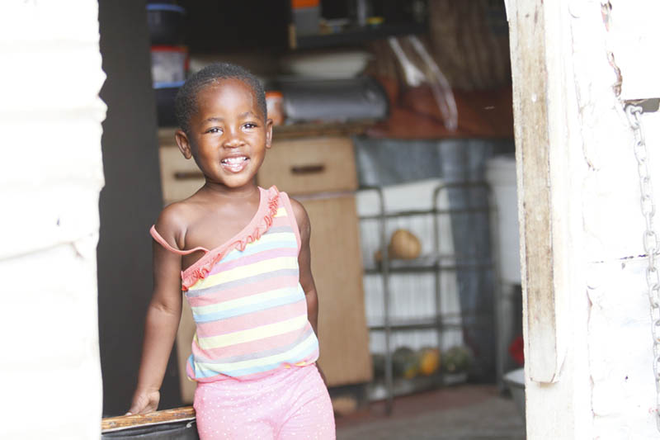

Please note that footages and pictures should be sent in with a short script of how the Day of Service was, with specific reference to any striking or unique event such as miracles, people getting born again, commendation by dignitries etc.
Upload to the website and send an email to blwdayofservice@loveworld360.com; you could also upload to kingscloud and send the link by email.
Thank you so kindly; we look forward to seeing your videos and pictures on Loveworld news.

